AgriSense: ML-Powered Smart Irrigation System



Mr.Sabih Jamal (Lecturer)

Project ID: BSIT-APDP-F22-E-106
Program: Post ADP-IT
Shift: Evening

Submitted By
Afaq Ahmed MTF24003517
Muhammad Zahid MTF24003536
Lateef Ahmad MTF24003541

DEPARTMENT OF INFORMATION SCIENCES
DIVISION OF SCIENCE & TECHNOLOGY
UNIVERSITY OF EDUCATION, LAHORE

December 17, 2025

AgriSense: ML-Powered Smart Irrigation System

BSIT Post ADP 2024-2026

A project submitted in partial fulfillment of the requirements for the award of the degree of BS in BSIT Post ADP

DEPARTMENT OF INFORMATION SCIENCES, DIVISION OF SCIENCE & TECHNOLOGY, UNIVERSITY OF EDUCATION, TOWNSHIP, LAHORE.

December 17, 2025

© Copyright 2025.

Project Approval and Endorsement

“I hereby declare that I have read this project documentation, and in my opinion this project is sufficient in terms of scope and quality for the award of the degree of BSIT Post ADP”

____________________ ____________________
Project Primary Supervisor External Examiner
Name: Mr.Sabih Jamal Name:
Designation: Lecturer Designation:
University of Education: university:

DECLARATION

We declare that the project entitled “AgriSense: ML-Powered Smart Irrigation System” is the result of our own research and development, except where due reference has been made. This project has not been accepted for any degree and is not concurrently submitted as a candidate for any other degree. If, at any time, this declaration is found to be incorrect, even after the award of the BS degree in Information Technology the university reserves the right to withdraw our BS Information Technology. degree.

Signature: _______________ Signature: _______________
Name: Afaq Ahmed Name: Lateef Ahmad
Date: Date:

Signature: _______________
Name: Muhammad Zahid
Date:

PLAGIARISM UNDERTAKING

We, the undersigned students, hereby declare that the project report entitled “AgriSense: ML-Powered Smart Irrigation System”, submitted, is our own original work. We solemnly declare and undertake that:
1)We have strictly adhered to the Higher Education Commission (HEC) and University of Education policies on Anti-Plagiarism and the ethical use of Artificial Intelligence (AI) tools, ensuring complete academic integrity and authenticity of our work.
2)We understand that any violation of plagiarism policies or unauthorized use of AI tools may result in disciplinary action, including rejection of the project, academic penalties, or other measures as prescribed by the University of Education.
3)If we are found guilty of any form of plagiarism in the above titled project, even after the award of the BS degree, the University reserves the right to withdraw or revoke our degree. Furthermore, the HEC and the University reserve the right to publish our names on their official websites as part of the record of students who have submitted plagiarized work.

Signature: _______________ Signature: _______________
Name: Afaq Ahmed Name: Lateef Ahmad
Date: Date:

Signature: _______________
Name: Muhammad Zahid
Date:
ACKNOWLEDGEMENT

We sincerely acknowledge the cooperation and support provided by Mr.Sabih Jamal (Lecturer), who has been a constant source of guidance throughout the course of this project. We would also like to express our gratitude to Dr Muhammad Akram Mujahid,(Assistant Professor) for his valuable assistance and encouragement during the development of this project.
We are deeply thankful to our friends and families for their continuous motivation and silent support, which enabled us to successfully complete this project.

1. Afaq Ahmed
2. Lateef Ahmad
3. Muhammad Zahid

Date: December 17, 2025

ABSTRACT
Pakistan's agriculture has significant challenges due to water scarcity, particularly in water-stressed areas like Bahawalpur, Multan, Rahim Yar Khan, Vehari, and Sahiwal. A lot of farmers still rely on guesswork or set irrigation schedules, which results in poor crop health, wasteful water consumption, higher expenses, and lower output. The efficacy of conventional irrigation techniques has been further diminished by climate variability and erratic weather.
For Punjab's small and medium-sized farms, AgriSense offers a low-cost smart irrigation solution based on the Internet of Things and machine learning. The system gathers field data in real time and stores it in a cloud database using sensors for temperature, humidity, and soil moisture that are coupled to an ESP32 microcontroller. The ideal irrigation time and necessary water amount are predicted by a Random Forest Regression model that was trained on locally gathered ground-truth environmental data.
AgriSense combines automated solenoid valve control, machine-learning forecasts, cloud-based data administration, and real-time sensing into a single platform. Based on anticipated crop water requirements, farmers can activate automatic irrigation, monitor field conditions, and obtain intelligent irrigation recommendations. In Pakistan's water-scarce areas, the technology increases water-use efficiency, decreases manual work, and promotes sustainable farming methods.

List of Tables

1.7 Table Acronyms and Abbreviations.....................................................................22
2.4 Table Functional Requirements...............................................…..................29
2.5 Table Non Functional Requirements............................................................31

List of Figures
3.1.1 Use Case login.....................................................................................................37
3.1.2 Use Case Moniter senser data …........................................................................38
3.13 Use Case Automatic irigation control..................................................................39
3.1.4 Use Case Manual Irrigation Control............…...................................................40
3.1.5 Use Case Configure threshold values .................................................................42
3.1.6 Use Case Receive Notifications..........................................................................43
3.1.7 Use Case Manage Multiple Farms......................................................................44
3.1.8 Use Case Logout.................................................................................................45
3.1.9 Use Case Identify User Role...............................................................................46
3.1.10 Use Case Collect Soil Moisture Data................................................................47
3.1.11 Use Case Collect Temperature Data..................................................................48
3.1.12 Use Case Collect Humidity Data......................................................................49
3.1.13 Use Case Store Sensor Data..............................................................................50
3.1.14 Use view Irrigation Status.................................................................................51
3.1.15 Use Case view Historical Data..........................................................................53
3.1.16 Use Case Middleman Farm Access...................................................................54
3.1.17 Use Case View System Dashboard...................................................................55
3.1.18 Use Case Detect Sensor Error...........................................................................56
3.1.19 Use Case Configure Data Update Frequency....................................................57
4.1.1 Architecture Diagram Description.......................................................................60
3.2.1 ERD.....................................................................................................................61
4.3.1 Data Flow Diagram Level 0...........….................................................................62
4.3.2 Data Flow Diagram Level 1...........….................................................................64
4.4.1 UML ……...........................................................................................................65
4.5.1 Sequence Diagram 1 login......…........................................................................66
4.5.2 Sequence Diagram 2 Sensor Data Collection and Storage......….......................67
4.5.3 Irrigation Decision and Log Generation.............................................................68

TABLE OF CONTENTS
Inner Title Page...............................................................................................................i
Statement of Submission...............................................................................................iii
Declaration....................................................................................................................iv
Plagiarism undertaking..................................................................................................v
Acknowledgement.........................................................................................................vi
Abstract........................................................................................................................vii
List of Tables...............................................................................................................viii
List of Figures...............................................................................................................ix
Table of contents............................................................................................................x
CHAPTER 1: Gathering & Analyzing Information..............................................12
Introduction..................................................................................................................13
Problem Statement.......................................................................................................14
Aim & Objectives.........................................................................................................15
Scope……....................................................................................................................16
Research Questions (for R & D project) .....................................................................17
Methodology.................................................................................................................18
Definitions, Acronyms and Abbreviations...................................................................22
CHAPTER 2: Software Requirement Specification .............................................24
Literature Review.........................................................................................................25
Stakeholders List..........................................................................................................26
Domain Requirements..................................................................................................30
Functional Requirements..............................................................................................31
Non-Functional Requirements.....................................................................................33
CHAPTER 3: Analysis ..............................................................................................35
Introduction..................................................................................................................36
Use cases......................................................................................................................36
Use case diagrams........................................................................................................37
CHAPTER 4: Design.................................................................................................58
Introduction..................................................................................................................59
Software Architecture Diagram....................................................................................59
ERD ……….................................................................................................................61

DFD ……….................................................................................................................62
UML Diagram..............................................................................................................64
Class Diagram..............................................................................................................66
Sequence Diagram........................................................................................................67

CHAPTER 1
Gathering and Analyzing Information

Introduction
Water scarcity continues to be one of the most critical challenges facing agriculture in Pakistan, particularly in regions such as Bahawalpur, Multan, Rahim Yar Khan, Vehari, and Sahiwal. Farmers in these water-stressed zones often rely on guesswork or fixed irrigation schedules, leading to over-irrigation or under-irrigation. These outdated practices waste water, reduce crop health, increase operational costs, and ultimately lower agricultural productivity.
With increasing climate variability and unpredictable weather patterns, traditional irrigation methods are no longer sufficient. Farmers require intelligent, real-time support tools that can accurately determine when and how much water their crops need. Many available systems either lack automation, are too costly for small farmers, or do not incorporate real-time soil and environmental conditions.
To address these gaps, AgriSense introduces a low-cost, IoT- and ML-based smart irrigation solution tailored specifically for small and medium farms in Punjab. Using soil moisture, temperature, and humidity sensors connected to an ESP32 microcontroller, AgriSense collects real-time field data and stores it in a cloud database. A machine learning model—trained from scratch using ground-truth environmental data from local fields—predicts irrigation timing and required water volume.
The system integrates IoT data collection, cloud storage, machine-learning predictions, and automated valve control into one unified framework. Farmers can monitor live field conditions, receive intelligent irrigation recommendations, and allow the system to automatically open and close solenoid valves based on predicted needs. This results in highly efficient water usage, improved crop yields, and reduced dependency on manual labor.
AgriSense ultimately aims to empower farmers with an affordable, data-driven, and user-friendly irrigation platform that supports sustainable agriculture and helps overcome Pakistan’s growing water-resource challenges.

Problem Statement
Farmers in Punjab’s agricultural regions continue to rely heavily on manual judgment, traditional practices, and fixed irrigation schedules to water their crops. These approaches often result in over-irrigation, which wastes scarce water resources, or under-irrigation, which causes crop stress and reduces yield. The lack of real-time soil and environmental insights further limits farmers’ ability to make informed decisions, especially in water-stressed districts such as Bahawalpur, Multan, Rahim Yar Khan, Vehari, and Sahiwal.
Although some digital irrigation tools exist, they suffer from significant shortcomings. Many are too expensive, not locally adaptable, or do not incorporate real-time data from the field. Existing systems often provide general recommendations rather than precise, automated irrigation control. Similarly, predictive models developed in research environments frequently lack integration with live sensor data or field-level deployment, making them impractical for everyday farm use.
There is a clear need for an affordable, real-time, and data-driven irrigation system that leverages IoT sensors and machine learning to accurately predict irrigation requirements and automate water delivery. A locally trained model, paired with cloud-based monitoring and an automated irrigation mechanism, can help farmers optimize water use, reduce operational effort, and improve crop productivity.
The absence of such an integrated, field-ready system hinders the adoption of smart farming practices and contributes to inefficient water management in Punjab’s small and medium farms.
AgriSense aims to address this gap by providing a low-cost, ML-powered, IoT-based irrigation solution tailored specifically to local conditions and crop needs.

Goal & Objectives
- Develop an intelligent and affordable IoT–ML based irrigation system that optimizes water usage for small and medium farms in Punjab.
- Automate the irrigation process using real-time soil moisture, temperature, and humidity data collected from IoT sensors.
- Build and train a locally adapted machine-learning model that accurately predicts the optimal irrigation timing and water volume for wheat crops.
- Minimize water wastage and operational costs by delivering only the required amount of water through automated solenoid valve control.
- Provide farmers with a simple, user-friendly web dashboard for live monitoring, irrigation history, and system alerts.
- Support sustainable farming practices and improve crop productivity through data-driven, real-time irrigation decisions.

Scope
The AgriSense project's scope is centered on gathering, analyzing, and applying agricultural field data to facilitate well-informed irrigation choices for wheat crops. Temperature, humidity, and soil moisture sensors placed throughout the field provide real-time data to the system. Field conditions pertinent to irrigation requirements are evaluated using this data.
Sensor readings are recorded by AgriSense's data processing and storage components for analysis and model training. The gathered data is analyzed by a machine learning model based on Random Forest regression to ascertain whether irrigation is necessary and to calculate the proper water requirements. Instead of providing completely independent irrigation control, the system offers irrigation recommendations.
A system interface that enables farmers or authorized users to log in, view sensor data, and receive irrigation recommendations is another aspect of the scope. Crop disease detection, yield prediction, and fertilizer management are not included in the data analysis; it is restricted to irrigation-related parameters.
The project is designed for water-stressed agricultural regions and aims to improve water-use efficiency by reducing over-irrigation and under-irrigation. Integration with external weather services, advanced automation, or additional crop types is outside the scope of this project.

Research Questions
- How can IoT sensors and an ESP32 microcontroller be integrated to create a reliable and low-cost smart irrigation system?
- How can automated solenoid valve control be synchronized with model predictions to minimize water wastage?
- How can a cloud-based database (Firebase) efficiently handle real-time sensor streams and irrigation logs for scalability?
- How can a web-based dashboard improve farmers’ ability to monitor field conditions and manage irrigation decisions?

Methodology

Available Methodologies
Developing an IoT–ML–based smart irrigation system can be approached using several established software engineering and research methodologies. Each methodology offers a different structure for planning, designing, implementing, and validating the system. The following are the most relevant methodologies available for this type of project:

1. Waterfall Methodology
A traditional, linear approach where each phase must be completed before moving to the next.
- Clear documentation
- Works well for stable, well-defined requirements
- Not flexible for changes during development

2. Iterative Model
The system is developed in small cycles, with each iteration improving upon the previous version.
- Allows refinement and continuous improvement
- Useful for systems requiring frequent updates
- Requires repeated testing in each iteration

3. Agile Methodology
A flexible, incremental methodology that focus on fast development, feedback, and continuous improvement.
- Suitable for projects with evolving requirements
- Encourages frequent testing and integration
- Requires active stakeholder involvement

4. Rapid Application Development (RAD)
Emphasizes quick prototyping and fast feedback cycles.
- Speeds up development
- Good for UI dashboards and ML model tests
- Less suited for very large and complex systems

5. V-Model (Verification & Validation Model)
An extension of Waterfall that pairs each development phase with a testing phase.
- Ensures strong testing and validation
- Suitable for hardware + software projects like IoT systems
- Less flexible when changing requirements

6. Spiral Model
Combines prototyping with risk analysis and repeated development cycles.
- Good for high-risk innovative projects
- Suitable for ML-heavy projects needing experimentation
- Time-consuming and complex

7. Prototype Model
Focuses on building quick prototypes to understand requirements before full development.
- Helps clarify user expectations
- Useful for dashboards, interfaces, and sensor data displays
- Risk of unclear shift from prototype to final system

Chosen Methodology
For the development of AgriSense, the Agile Methodology has been selected as the most suitable approach. This project involves integrating multiple components—IoT hardware, cloud storage, machine-learning models, automated irrigation mechanisms, and a user interface—which evolve continuously based on testing and real-world field conditions. Agile provides the flexibility needed to develop these components in parallel, refine them iteratively, and incorporate improvements throughout the project lifecycle.
Agile allows the project team to work in short development cycles (sprints), where IoT sensor integration, data collection, ML model training, dashboard features, and valve control logic can be implemented and tested incrementally. As sensor data patterns, model performance, and field conditions change over time, Agile supports rapid adaptation and continuous enhancement of the system.
The selected methodology also enables close feedback loops with stakeholders—such as farmers, supervisors, and field testers—ensuring that the system remains practical, user-friendly, and aligned with real agricultural needs. This approach is particularly effective for smart agriculture projects, where environmental conditions, data behavior, and hardware performance must be evaluated and adjusted repeatedly.
By choosing Agile, AgriSense can be developed efficiently, validated continuously, and improved iteratively, resulting in a more accurate, reliable, and farmer-centric smart irrigation solution.

Reasons for Chosen Methodology

The Agile Methodology is selected for the AgriSense project due to the evolving nature of smart irrigation systems, sensor-based data collection, and real-time field conditions. The following reasons justify the selection of Agile:

Supports Iterative Development
The accuracy of sensor data, irrigation management logic, and system performance must all be continuously improved for AgriSense. Agile encourages iterative development cycles, which enable progressive improvement through frequent testing and feedback.

Handles Changing Requirements Effectively
Environmental conditions, sensor behavior, and farm-specific needs may change during deployment. Agile allows the system to adapt to such changes without affecting the overall project structure.

Enables Parallel Development of System Components
The project consists of multiple components such as sensor integration, data storage, irrigation control, and dashboard development. Agile enables these components to be developed simultaneously through short and manageable sprints.

Encourages Continuous Testing and Validation
Frequent testing of sensors, data accuracy, and irrigation actions is essential for AgriSense. Agile promotes continuous testing, helping detect issues early and ensuring system reliability.

Improves User and Stakeholder Feedback Integration
Farmers and middlemen can provide feedback at the end of each sprint. This ensures the system remains practical, user-friendly, and aligned with real farming requirements.

Provides Flexibility for System Optimization
As more field data is collected, system behavior and decision rules can be improved. Agile allows easy adjustment and optimization without requiring major redesign.

Definitions, Acronyms and Abbreviations

Definitions
- Smart Irrigation System
An automated irrigation setup that uses real-time data and intelligent algorithms to determine the exact amount of water required by crops.
- Machine Learning (ML)
A field of artificial intelligence that enables systems to learn patterns from data and make predictions without being explicitly programmed.
- IoT (Internet of Things)
A network of interconnected devices (such as sensors and microcontrollers) that collect and share data over the internet.
- Soil Moisture Sensor
A device used to measure the amount of water present in the soil, helping determine irrigation needs.
- Solenoid Valve
An electronically controlled valve used to start or stop the flow of water automatically.
- Cloud Database
An online data storage service that stores, manages, and synchronizes real-time sensor data.
- ESP32 Microcontroller
A low-cost microcontroller with Wi-Fi capability used to collect data from sensors and send it to the cloud.
- Web Dashboard
A web-based interface that displays live sensor data, irrigation history, and system alerts for farmers.

Acronyms and Abbreviations

Term | Meaning
IoT | Internet of Things
ML | Machine Learning
API | Application Programming Interface
ESP32 | A Wi-Fi-enabled microcontroller used in IoT systems
RF | Random Forest (Machine Learning Algorithm)
DB | Database
UI | User Interface
AWS | Amazon Web Services
HTTP | Hypertext Transfer Protocol
CSV | Comma-Separated Values (data storage format)
SRS | Software Requirement Specification
DFD | Data Flow Diagram
ERD | Entity Relationship Diagram

CHAPTER 2
Software Requirement Specification

Literature Review
Agriculture is severely hampered by water scarcity and ineffective irrigation techniques, especially in emerging nations like Pakistan. Water waste and insufficient crop watering are common outcomes of conventional irrigation techniques based on set timetables or farmer intuition. Data-driven irrigation systems can greatly increase crop output and water use efficiency, according to recent studies.
IoT-based sensor systems have been extensively researched for real-time temperature, humidity, and soil moisture monitoring. Soil moisture is thought to be the most accurate measure of crop water requirements among these factors. Research indicates that integrating environmental and soil data allows for more precise irrigation choices than conventional approaches.
Because machine learning models can handle nonlinear interactions and noisy sensor data, Random Forest Regression in particular has shown promise in estimating irrigation requirements. Predictive models offer adaptive irrigation suggestions under changing environmental conditions, in contrast to rule-based or threshold-based methods.
In order to help farmers by offering practical irrigation recommendations, existing literature also highlights the significance of centralized data storage and decision-support platforms. Adoption is still hampered by issues like inadequate localized data and cost.
The integration of machine learning and real-time sensing for effective irrigation management is generally supported by the literature. In line with these conclusions, the AgriSense project supports well-informed irrigation decisions in water-stressed agricultural areas by utilizing environmental sensor data and a Random Forest regression model.

Stakeholder Characteristics
The AgriSense smart irrigation system involves three primary stakeholders who directly interact with or benefit from the system. Understanding their characteristics, roles, technical abilities, and expectations ensures that the system is user-friendly, efficient, and aligned with real-world agricultural needs.

1. Farmer

Description
The primary end-user of the AgriSense system. The farmer operates the irrigation system, monitors soil and crop conditions, and uses system recommendations to manage farm irrigation.

Characteristics
- May have limited technical skills (especially in rural areas).
- Works in challenging field environments.
- Focused on crop yield, water conservation, and ease of use.

Needs
- Simple and intuitive mobile or web interface.
- Easy-to-understand irrigation recommendations.
- Reliable real-time data (soil moisture, temperature, humidity).
- Alerts for irrigation schedules, hardware faults, and water shortages.

Responsibilities
- Accessing irrigation recommendations.
- Monitoring system alerts.
- Operating irrigation pumps when recommended (if system is semi-automatic).

Expectations
- Minimum effort to operate system.
- Accurate recommendations.
- Low-cost, durable IoT hardware.

2. Middle-Man / Field Assistant

Description
A technically knowledgeable intermediary who helps farmers operate the system. They can access the dashboard, interpret readings, configure devices, and assist with troubleshooting.

Characteristics
- Moderate technical knowledge of mobile applications and IoT hardware.
- Acts as a bridge between the farmer and the system.
- Often a local agricultural helper or technician.

Needs
- Access to system settings and configuration tools.
- Guides to interpret model predictions and sensor readings.
- Ability to perform minor maintenance (sensor positioning, Wi-Fi setup, etc.)

Responsibilities
- Helping farmers understand and use the application.
- Monitoring system data on behalf of the farmer.
- Supporting farmers in making irrigation decisions.
- Reporting faults or issues to the admin.

Expectations
- Clear system feedback.
- Stable connectivity and accurate sensor readings.
- Quick troubleshooting support.

3. Admin / System Operator

Description
A technically skilled stakeholder who handles system configuration, manages user accounts, ensures data quality, and trains the machine-learning model using historical sensor and irrigation data.

Characteristics
- Strong technical background (IoT, databases, ML).
- Familiar with backend tools, data analytics, and sensor calibration processes.
- Responsible for maintaining system reliability.

Needs
- Access to complete farm and sensor datasets.
- Tools for model training, validation, and updating.
- Monitoring dashboards for hardware health and device connectivity.

Responsibilities
- Managing farmer and middle-man accounts.
- Accessing and cleaning sensor data for ML training.
- Updating irrigation prediction models.
- Monitoring device health, network status, and data logs.

Expectations
- High system reliability with minimal downtime.
- Accurate sensor data for effective model training.
- Secure access to backend administrative tools.

Domain Requirements
- The system must operate effectively within the agricultural domain of Punjab, supporting wheat crops by interpreting soil moisture, temperature, and humidity data according to local soil types and climatic conditions.
- IoT hardware (ESP32, sensors, solenoid valves) must function reliably in outdoor field environments, providing continuous real-time data and low-power operation suitable for rural agricultural areas.
- The machine-learning model must be trained on locally collected field data, accurately predicting irrigation timing and water requirements, and must support ongoing retraining based on real-world agricultural patterns in Pakistan.
- The cloud database (Firebase) must efficiently handle real-time data storage, synchronization, and communication between IoT devices, the dashboard, and backend APIs, even under unstable or low-bandwidth network conditions common in rural Pakistan.
- The automation system must precisely control solenoid valves based on ML predictions while supporting manual override through the dashboard to ensure safe, flexible, and context-aware irrigation management.
- The user dashboard must remain lightweight and accessible on low-end smartphones commonly used by farmers in Pakistan, providing clear access to real-time sensor readings, irrigation history, and system alerts.
- All IoT devices, wiring, and electrical components must comply with Pakistan Standards and Quality Control Authority (PSQCA) guidelines for low-voltage agricultural equipment, ensuring safety, durability, and proper field installation under Pakistani environmental and regulatory conditions.

Functional Requirements
No | Requirement | Description
FR1 | User Login | The system shall allow registered users (Farmer and Middleman) to log in using a valid username and password before accessing any system functionality.
FR2 | User Logout | The system shall allow the logged-in user to securely log out of the system at any time.
FR3 | User Role Identification | The system shall identify the role of the user (Farmer or Middleman) after successful login and provide access based on the assigned role. Depends on FR1.
FR4 | Register Farm Profile | The system shall allow a farmer or middleman to create and manage a farm profile including farm name, location, crop type, and field size.
FR5 | Soil Moisture Data Collection | The system shall collect soil moisture data from sensors installed in the farm field at regular intervals.
FR6 | Temperature Data Collection | The system shall collect environmental temperature data through sensors for irrigation decision-making.
FR7 | Humidity Data Collection | The system shall collect humidity data from sensors to support irrigation analysis.
FR8 | Sensor Data Storage | The system shall store collected sensor data (soil moisture, temperature, humidity) in the system database for future reference and analysis. Depends on FR5, FR6, FR7.
FR9 | Real-Time Data Monitoring | The system shall display real-time sensor data to the user through a simple and user-friendly interface.
FR10 | Irrigation Status Monitoring | The system shall allow users to view the current irrigation status (ON/OFF) of the field.
FR11 | Automatic Irrigation Control | The system shall automatically turn irrigation ON or OFF based on predefined soil moisture threshold values. Depends on FR5.
FR12 | Threshold Value Configuration | The system shall allow authorized users to set or update soil moisture threshold values used for automatic irrigation.
FR13 | Notification Alerts | The system shall notify the user when soil moisture reaches critical levels or when irrigation is activated or stopped.
FR14 | Historical Data Viewing | The system shall allow users to view historical sensor data records for analysis and decision support.
FR15 | Middleman Assistance Access | The system shall allow a middleman to access and manage farm data on behalf of the farmer when the farmer lacks technical knowledge.
FR16 | Multi-Farm Management | The system shall allow a middleman to manage multiple farms under different farmer profiles. Depends on FR16.
FR17 | System Dashboard | The system shall provide a dashboard showing summarized information such as current soil moisture, temperature, humidity, and irrigation status.
FR18 | Error Detection | The system shall detect and notify the user in case of sensor failure or data unavailability.
FR19 | Data Update Frequency Control | The system shall allow configuration of sensor data update intervals based on system capability and farm requirements.

Non-Functional Requirements

No | Requirement | Description
NFR1 | Security | All access to the AgriSense system shall require user authentication using a valid username and password. Only authorized users (Farmer or Middleman) shall be able to access system functions based on their assigned role.
NFR2 | Access Control | The system shall restrict user access according to defined roles. Farmers shall access only their own farm data, while middlemen shall access only the farms assigned to them.
NFR3 | Data Privacy | Farm data, sensor readings, and user information shall be protected from unauthorized access and modification.
NFR4 | Data Integrity | The system shall ensure that sensor data stored in the database is accurate, consistent, and protected from unintended alteration.
NFR5 | Availability | The system shall be available for use at all times except during scheduled maintenance or unexpected system failure.
NFR6 | Reliability | The system shall continue to operate correctly and consistently under normal farming and environmental conditions.
NFR7 | Performance | The system shall display sensor data and irrigation status updates within an acceptable response time after data is received.
NFR8 | Scalability | The system shall support an increasing number of farms, sensors, and users without requiring major system redesign.
NFR9 | Compatibility | The system shall be compatible with commonly used sensors and devices used in smart irrigation systems.
NFR10 | Usability | The system interface shall be simple, clear, and easy to understand for farmers with limited technical knowledge.
NFR11 | Maintainability | The system shall be designed so that updates, fixes, and enhancements can be performed without disrupting system operation.
NFR12 | Fault Tolerance | The system shall handle sensor failures or communication errors gracefully without causing system crashes.
NFR13 | Error Handling | The system shall detect invalid operations and unexpected errors and provide appropriate error messages to the user.
NFR14 | Logging | All important system activities, including login attempts and irrigation actions, shall be logged for monitoring and troubleshooting purposes.
NFR15 | Data Backup | The system shall periodically back up stored data to prevent data loss due to system failure.
NFR16 | Response Time | User requests such as viewing data or controlling irrigation shall be processed within an acceptable time limit.
NFR17 | System Safety | The system shall prevent unsafe irrigation operations that may damage crops or waste water.
NFR18 | Portability | The system shall be deployable on commonly available hardware platforms used in agricultural environments.
NFR19 | Resource Efficiency | The system shall efficiently use network, storage, and power resources to ensure stable operation in rural areas.
NFR20 | Compliance | The system shall comply with relevant agricultural and data protection guidelines applicable to smart irrigation systems.

CHAPTER 3:

Analysis

UC Number: 1.1
UC Name: Login
Functional Requirement No: FR1
Primary Actors/Stakeholders: Farmer, Middleman
Secondary Actors/Stakeholders: None
Description:
To access the AgriSense system, users must authenticate themselves by logging in using valid credentials.
Preconditions:
- The user must have a valid registered account.
Main Success Scenario (MSS):
- The user opens the AgriSense system.
- The system prompts the user to enter username and password.
- The user enters login credentials.
- The system validates the credentials.
- The system identifies the user role.
- The system grants access to authorized functions.
Alternative Scenario:
- Invalid username or password entered.
- User already logged into the system.
Post Conditions:
- The user is successfully logged into the system.
- The user can access features based on their role.

Extensions:
- The system displays an error message if authentication fails.
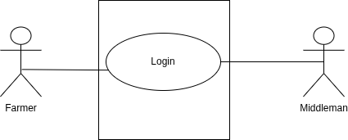

UC Number: 1.2
UC Name: Monitor Sensor Data
Functional Requirement No: FR9
Primary Actors/Stakeholders: Farmer, Middleman
Secondary Actors/Stakeholders: Sensors
Description:
Allows users to view real-time soil moisture, temperature, and humidity data collected from sensors.
Preconditions:
- User must be logged into the system.
- Sensors must be active.
Main Success Scenario (MSS):
- The user accesses the dashboard.
- The system retrieves real-time sensor data.
- The system displays current soil moisture, temperature, and humidity values.
Alternative Scenario:
- Sensor data unavailable.

Post Conditions:
- User successfully views current sensor data.
Extensions:
- The system shows a warning if sensor data is missing.
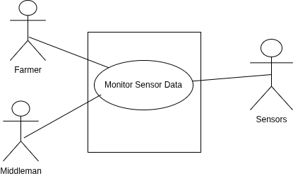

UC Number: 1.3
UC Name: Automatic Irrigation Control
Functional Requirement No: FR11
Primary Actors/Stakeholders: System
Secondary Actors/Stakeholders: Farmer, Middleman
Description:
The system automatically controls irrigation based on predefined soil moisture thresholds.
Preconditions:
- Soil moisture sensors must be operational.
- Threshold values must be defined.

Main Success Scenario (MSS):
- The system continuously monitors soil moisture levels.
- The system compares data with threshold values.
- The system activates irrigation when moisture is below threshold.
- The system stops irrigation when the desired level is reached.
Alternative Scenario:
- Sensor malfunction detected.
Post Conditions:
- Irrigation state is updated automatically.
Extensions:
- The system sends alerts if abnormal readings occur.
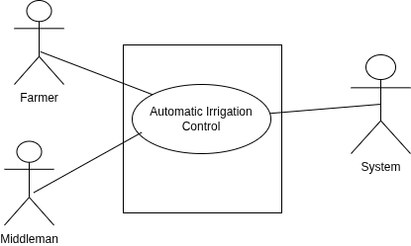

UC Number: 1.4
UC Name: Manual Irrigation Control
Functional Requirement No: FR12
Primary Actors/Stakeholders: Farmer, Middleman
Secondary Actors/Stakeholders: None
Description:
Allows users to manually start or stop irrigation.
Preconditions:
- User must be logged into the system.
Main Success Scenario (MSS):
- The user selects manual control option.
- The user chooses to turn irrigation ON or OFF.
- The system updates the irrigation state.
Alternative Scenario:
- System unavailable.
Post Conditions:
- Irrigation status is manually updated.
Extensions:
- The system logs the manual action.
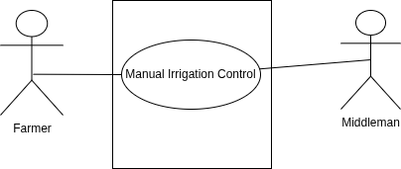

UC Number: 1.5
UC Name: Configure Threshold Values
Functional Requirement No: FR13
Primary Actors/Stakeholders: Farmer, Middleman
Secondary Actors/Stakeholders: None
Description:
Allows authorized users to configure soil moisture threshold values for automatic irrigation.
Preconditions:
- User must be logged in.
- User must have configuration privileges.
Main Success Scenario (MSS):
- The user opens threshold settings.
- The user enters new threshold values.
- The system validates the input.
- The system saves updated thresholds.
Alternative Scenario:
- Invalid threshold values entered.
Post Conditions:
- New threshold values are applied.

Extensions:
- System rejects invalid configurations.
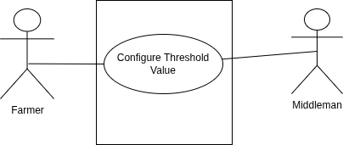

UC Number: 1.6
UC Name: Receive Notifications
Functional Requirement No: FR14
Primary Actors/Stakeholders: Farmer, Middleman
Secondary Actors/Stakeholders: System
Description:
The system notifies users about critical soil moisture levels or irrigation events.
Preconditions:
- Notification feature enabled.
Main Success Scenario (MSS):
- The system detects a critical condition.
- The system generates a notification.
- The user receives the alert.
Alternative Scenario:
- Notification delivery fails.
Post Conditions:
- User is informed of system status.

Extensions:
- Notification is retried or logged.
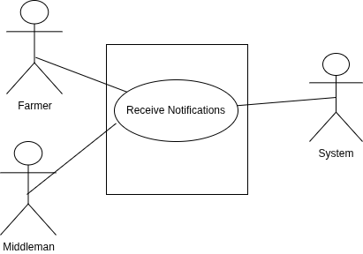

UC Number: 1.7
UC Name: Manage Multiple Farms
Functional Requirement No: FR17
Primary Actors/Stakeholders: Middleman
Secondary Actors/Stakeholders: Farmer
Description:
Allows middlemen to manage and monitor multiple farms on behalf of farmers.
Preconditions:
- Middleman must be authorized.
- Farms must be registered.
Main Success Scenario (MSS):
- The middleman selects a farm profile.
- The system loads the selected farm data.
- The middleman performs monitoring or control actions.

Alternative Scenario:
- Unauthorized farm access attempt.
Post Conditions:
- Selected farm is managed successfully.
Extensions:
- System denies access if authorization fails.
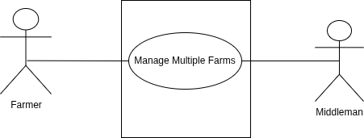

UC Number: 1.8
UC Name: Logout
Functional Requirement No: FR2
Primary Actors/Stakeholders: Farmer, Middleman
Secondary Actors/Stakeholders: None
Description:
Allows the user to securely log out from the AgriSense system.
Preconditions:
- The user must be logged into the system.
Main Success Scenario (MSS):
- The user selects the logout option.
- The system terminates the active session.
- The system redirects the user to the login page.

Alternative Scenario:
- Session already expired.
Post Conditions:
- The user is logged out of the system.
Extensions:
- System clears cached session data.
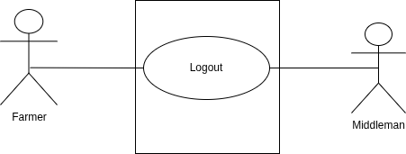

UC Number: 1.9
UC Name: Identify User Role
Functional Requirement No: FR3
Primary Actors/Stakeholders: System
Secondary Actors/Stakeholders: Farmer, Middleman
Description:
The system determines the role of the user after successful login.
Preconditions:
- User must be authenticated.
Main Success Scenario (MSS):
- The system retrieves user credentials.
- The system determines the assigned role.
- The system enables role-based access.
Alternative Scenario:
- Role not assigned.
Post Conditions:
- User permissions are activated.
Extensions:
- System restricts access if role is undefined.
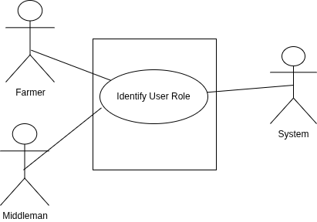

UC Number: 2.0
UC Name: Collect Soil Moisture Data
Functional Requirement No: FR5
Primary Actors/Stakeholders: Sensors
Secondary Actors/Stakeholders: System
Description:
The system collects soil moisture data from field sensors.

Preconditions:
- Sensors must be installed and active.
Main Success Scenario (MSS):
- Sensors measure soil moisture.
- Data is transmitted to the system.
- System receives and records data.
Alternative Scenario:
- Sensor communication failure.

Post Conditions:
- Soil moisture data is collected.
Extensions:
- System flags sensor error.
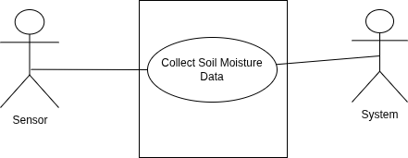

UC Number: 2.1
UC Name: Collect Temperature Data
Functional Requirement No: FR6
Primary Actors/Stakeholders: Sensors
Secondary Actors/Stakeholders: System
Description:
The system collects environmental temperature data.
Preconditions:
- Temperature sensors operational.
Main Success Scenario (MSS):
- Sensors record temperature.
- Data is sent to the system.
- System stores the data.

Alternative Scenario:
- Sensor not responding.
Post Conditions:
- Temperature data recorded.
Extensions:
- System logs sensor failure.
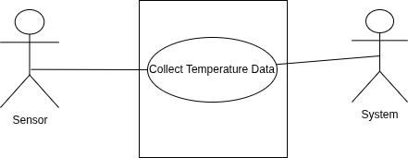

UC Number: 2.2
UC Name: Collect Humidity Data
Functional Requirement No: FR7
Primary Actors/Stakeholders: Sensors
Secondary Actors/Stakeholders: System
Description:
The system collects humidity data from sensors.
Preconditions:
- Humidity sensors active.
Main Success Scenario (MSS):
- Sensor measures humidity.
- Data transmitted to system.
- System stores humidity data.
Alternative Scenario:
- Data transmission error.
Post Conditions:
- Humidity data stored.
Extensions:
- Error logged by system.
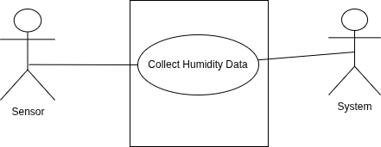

UC Number: 2.3
UC Name: Store Sensor Data
Functional Requirement No: FR8
Primary Actors/Stakeholders: System
Secondary Actors/Stakeholders: Sensors
Description:
The system stores all collected sensor data securely.
Preconditions:
- Sensor data received.
Main Success Scenario (MSS):
- System receives sensor readings.
- System validates the data.
- System stores data in database.
Alternative Scenario:
- Data validation fails.
Post Conditions:
- Sensor data saved successfully.
Extensions:
- System discards invalid data.
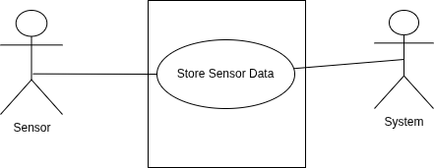

UC Number: 2.4
UC Name: View Irrigation Status
Functional Requirement No: FR10
Primary Actors/Stakeholders: Farmer, Middleman
Secondary Actors/Stakeholders: System
Description:
Allows users to view the current irrigation state.

Preconditions:
- User logged in.
Main Success Scenario (MSS):
- User opens irrigation status screen.
- System displays current status.
Alternative Scenario:
- Status unavailable.
Post Conditions:
- User views irrigation state.
Extensions:
- System refreshes status automatically.
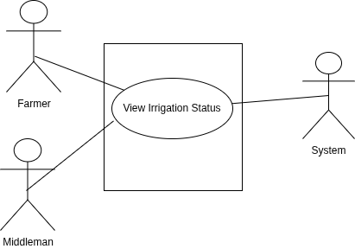

UC Number: 2.5
UC Name: View Historical Data
Functional Requirement No: FR15
Primary Actors/Stakeholders: Farmer, Middleman
Secondary Actors/Stakeholders: System
Description:
Allows users to view historical sensor data.
Preconditions:
- User authenticated.
Main Success Scenario (MSS):
- User selects history option.
- System retrieves stored data.
- System displays data.
Alternative Scenario:
- No data available.
Post Conditions:
- Historical data viewed.
Extensions:
- System filters data by date.
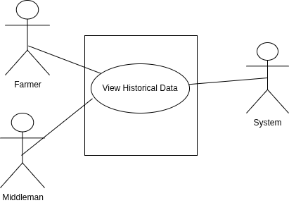

UC Number: 2.6
UC Name: Middleman Farm Access
Functional Requirement No: FR16
Primary Actors/Stakeholders: Middleman
Secondary Actors/Stakeholders: Farmer
Description:
Allows middleman to assist farmers by managing their farm data.
Preconditions:
- Authorization granted.
Main Success Scenario (MSS):
- Middleman selects farmer profile.
- System verifies permission.
- Farm data becomes accessible.
Alternative Scenario:
- Unauthorized access attempt.
Post Conditions:
- Farm accessed successfully.
Extensions:
- Access denied with warning.
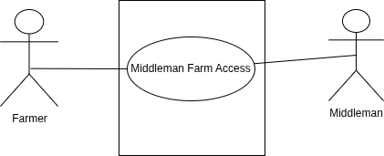

UC Number: 2.7
UC Name: View System Dashboard
Functional Requirement No: FR18
Primary Actors/Stakeholders: Farmer, Middleman
Secondary Actors/Stakeholders: System
Description:
Displays summarized system information on dashboard.
Preconditions:
- User logged in.
Main Success Scenario (MSS):
- User opens dashboard.
- System displays key data.
Alternative Scenario:
- Data loading delay.
Post Conditions:
- Dashboard displayed.

Extensions:
- System refreshes data automatically.
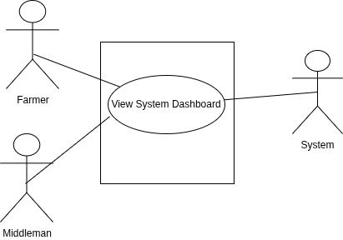

UC Number: 2.8
UC Name: Detect Sensor Error
Functional Requirement No: FR19
Primary Actors/Stakeholders: System
Secondary Actors/Stakeholders: Farmer, Middleman
Description:
The system detects sensor failures.
Preconditions:
- Sensors active.
Main Success Scenario (MSS):
- System monitors sensor signals.
- System detects abnormal behavior.
- System generates error alert.
Alternative Scenario:
- Temporary communication loss.
Post Conditions:
- Sensor issue identified.
Extensions:
- Alert sent to user.
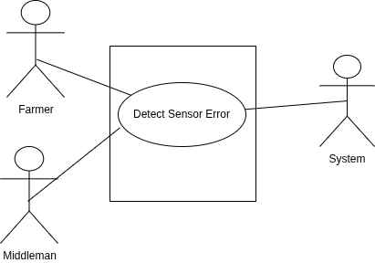

UC Number: 2.9
UC Name: Configure Data Update Frequency
Functional Requirement No: FR20
Primary Actors/Stakeholders: Farmer, Middleman
Secondary Actors/Stakeholders: System
Description:
Allows configuration of sensor data update intervals.
Preconditions:
- User authorized.
Main Success Scenario (MSS):
- User opens settings.
- User selects update interval.
- System applies changes.
Alternative Scenario:
- Invalid interval selected.
Post Conditions:
- Update frequency configured.
Extensions:
- System reverts to default value.

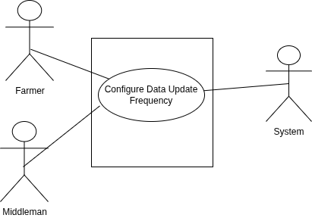

CHAPTER 4
Design

Architecture Diagram Description

1. IoT Sensor Layer
This layer includes the soil moisture, temperature, and humidity sensors installed in the field. These sensors gather real-time environmental data essential for determining irrigation needs.

2. ESP32 Microcontroller
The ESP32 reads data from all sensors and sends it to the cloud (Firebase). It also receives irrigation commands from the backend and controls the solenoid valve accordingly.

3. Cloud Layer (Firebase)
Firebase serves as the real-time database where sensor readings, irrigation history, alerts, and system logs are stored. This cloud storage acts as the central communication hub between the IoT device, web dashboard, and backend.

4. Backend Layer (FastAPI Server)
The FastAPI backend:
- fetches sensor data from Firebase
- processes it
- sends it to the ML model
- generates irrigation decisions
- communicates final commands to the ESP32
This layer ensures the entire system behaves intelligently and automatically.

5. Machine Learning Model
A Random Forest Regression model trained on local field data predicts:
- when irrigation is needed
- how much water should be applied
It adapts continuously as more field data is collected.

6. Web Dashboard (User Interface Layer)
Farmers use this dashboard to:
- monitor live sensor data
- check irrigation history
- receive alerts
- manually start or stop irrigation
The dashboard communicates with Firebase and backend APIs.

7. Solenoid Valve Unit
The final stage, where water flow is physically controlled. The valve turns ON/OFF automatically based on ML predictions or manually via the dashboard.
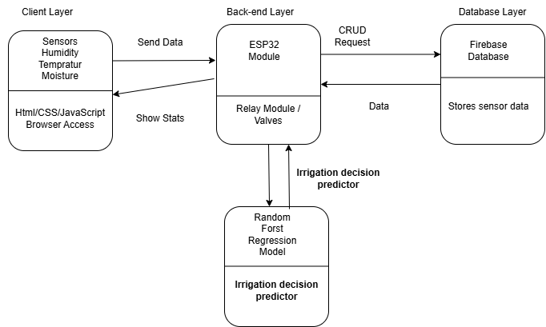

ERD

Farmer (1) ← Device (Many)
Device.farmer_id → Farmer.farmer_id

Device (1) ← SensorData (Many)
SensorData.device_id → Device.device_id

Device (1) ← IrrigationLog (Many)
IrrigationLog.device_id → Device.device_id

SensorData (1) ← IrrigationLog (Many)
IrrigationLog.sensor_id → SensorData.sensor_id
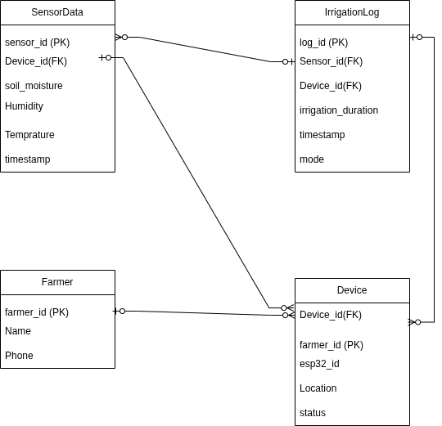

DFD 0

External Entities
- Farmer (Sends commands, views data)
- Sensors (Send soil moisture, temp, humidity)

Main Process
- Process 0: AgriSense Smart Irrigation System

Data Store
- D1: Cloud Database (Firebase)

Data Flows
- Sensors → Sensor Data → System
- Farmer → Commands / Queries → System
- System → Alerts / Dashboard Output → Farmer
- System → Store & Retrieve Data → Database

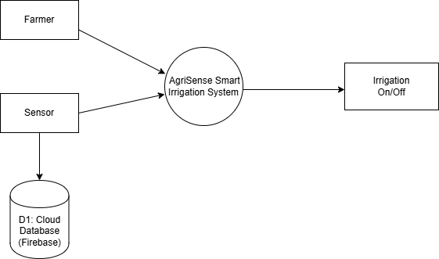

DFD Level 1 — Subprocesses

1.0 Collect Sensor Data
- ESP32 receives sensor readings
- Sends to system

2.0 Store & Retrieve Data
- Stores sensor data into database
- Retrieves data for dashboard

3.0 Predict Irrigation Need
- ML model analyzes soil moisture, humidity, temperature
- Generates irrigation decision

4.0 Control Irrigation Valve
- Turns valve ON/OFF
- Creates irrigation logs

5.0 Send Alerts & Dashboard Data
- Farmer receives data & alerts
- Dashboard updates in real time

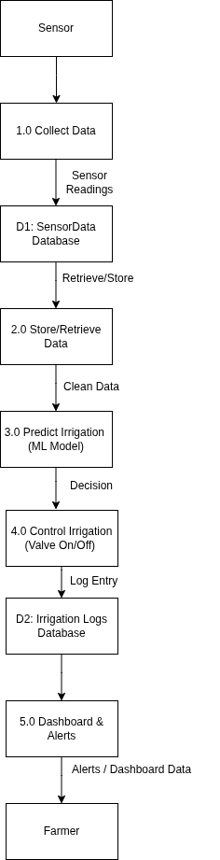
UML Diagram

Farmer → Device
1-to-Many
One farmer has many devices.

Device → SensorData
1-to-Many
One device sends many sensor readings.

Device → IrrigationLog
1-to-Many
One device generates many irrigation logs.

SensorData → IrrigationLog
1-to-Many
One sensor reading may influence many irrigation logs.

MLModel → SensorData (uses)
Model uses sensor readings as input.
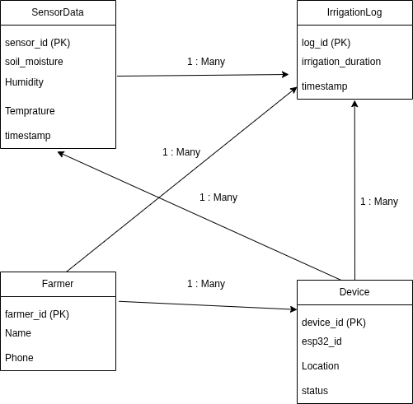

Class Diagram
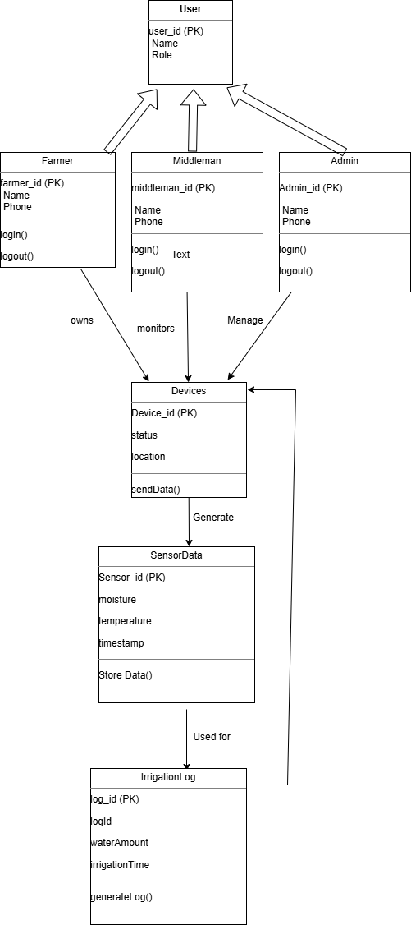

Sequence Diagram
Sequence Diagram 1: User Login

Description:
This sequence diagram illustrates the login process in the AgriSense system. The user enters login credentials, which are sent to the AgriSense system for authentication. The system validates the credentials by querying the database. After receiving the validation result, the system returns a success or failure response to the user. Solid arrows represent request messages, while dotted arrows represent response messages.

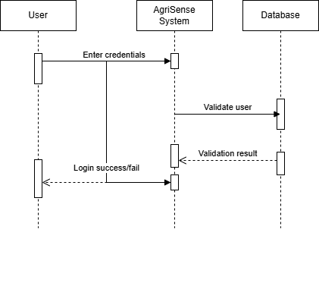
Sequence Diagram 2: Sensor Data Collection and Storage

Description:
This sequence diagram represents the process of sensor data collection in the AgriSense system. The device sends soil-related data to the AgriSense system. The system processes the received data and stores it in the database. Upon successful storage, a confirmation is returned to the system, which then acknowledges the device. Solid arrows indicate data transmission and storage requests, whereas dotted arrows indicate acknowledgements and confirmations.

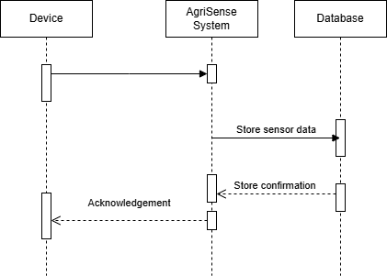

Sequence Diagram 3: Irrigation Decision and Log Generation
Description:
This sequence diagram shows how the AgriSense system generates irrigation decisions based on sensor data. The farmer requests irrigation status from the system. The system retrieves the latest sensor data, generates an irrigation log, and stores it in the database. Finally, the system sends the irrigation information back to the farmer. Solid arrows represent processing and data requests, while dotted arrows represent returned data and confirmations.

